**PIZZA SALES SQL QUERIES**

# A. KPI’s

**1. Total Revenue:**

SELECT SUM(total_price) AS Total_Revenue FROM pizza_sales;

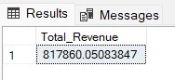

## 2. Average Order Value

SELECT (SUM(total_price) / COUNT(DISTINCT order_id)) AS Avg_order_Value

FROM pizza_sales

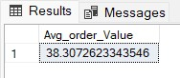

## 3. Total Pizzas Sold

SELECT SUM(quantity) AS Total_pizza_sold FROM pizza_sales

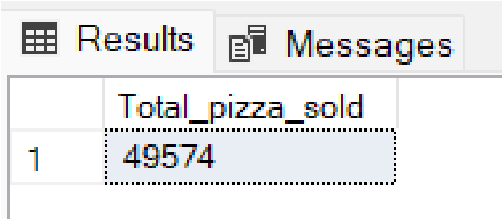

## 4. Total Orders

SELECT COUNT(DISTINCT order_id) AS Total_Orders FROM pizza_sales

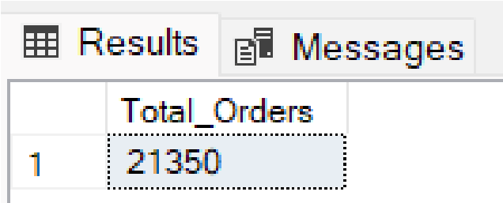

## 5. Average Pizzas Per Order

SELECT CAST(CAST(SUM(quantity) AS DECIMAL(10,2)) / CAST(COUNT(DISTINCT order_id) AS DECIMAL(10,2)) AS DECIMAL(10,2))

AS Avg_Pizzas_per_order

FROM pizza_sales

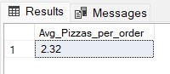

# B. Daily Trend for Total Orders

SELECT DATENAME(DW, order_date) AS order_day, COUNT(DISTINCT order_id) AS total_orders

FROM pizza_sales

GROUP BY DATENAME(DW, order_date) ***Output:***

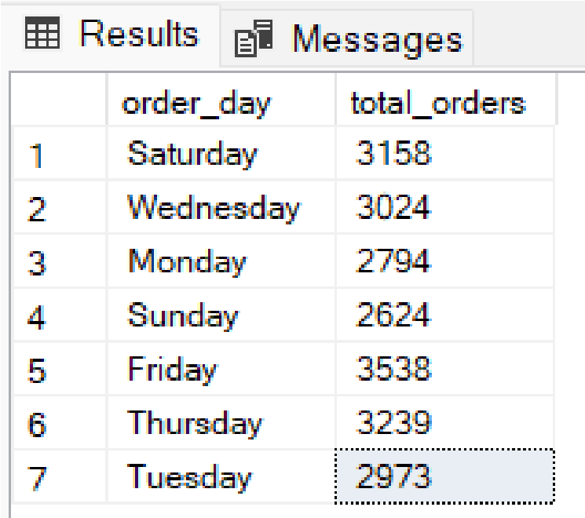

# C. Monthly Trend for Orders

select DATENAME(MONTH, order_date) as Month_Name, COUNT(DISTINCT order_id) as Total_Orders from pizza_sales

GROUP BY DATENAME(MONTH, order_date)***Output***

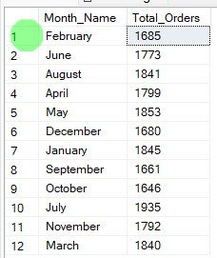

# D. % of Sales by Pizza Category

SELECT pizza_category, CAST(SUM(total_price) AS DECIMAL(10,2)) as total_revenue,

CAST(SUM(total_price) * 100 / (SELECT SUM(total_price) from pizza_sales)

AS DECIMAL(10,2)) AS PCT

FROM pizza_sales

GROUP BY pizza_category

## *Output*

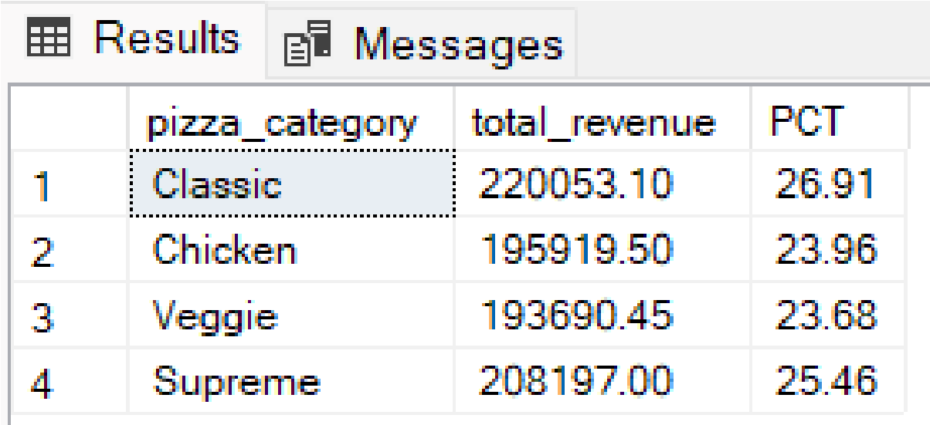

# E. % of Sales by Pizza Size

SELECT pizza_size, CAST(SUM(total_price) AS DECIMAL(10,2)) as total_revenue,

CAST(SUM(total_price) * 100 / (SELECT SUM(total_price) from pizza_sales)

AS DECIMAL(10,2)) AS PCT

FROM pizza_sales

GROUP BY pizza_size

ORDER BY pizza_size

## *Output*

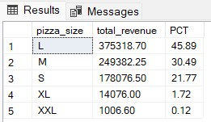

# F. Total Pizzas Sold by Pizza Category

SELECT pizza_category, SUM(quantity) as Total_Quantity_Sold

FROM pizza_sales

WHERE MONTH(order_date) = 2

GROUP BY pizza_category

ORDER BY Total_Quantity_Sold DESC

***Output***

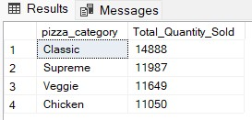

# G. Top 5 Pizzas by Revenue

SELECT Top 5 pizza_name, SUM(total_price) AS Total_Revenue

FROM pizza_sales

GROUP BY pizza_name

ORDER BY Total_Revenue DESC

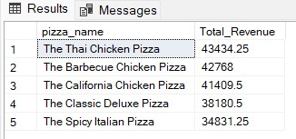

# H. Bottom 5 Pizzas by Revenue

SELECT Top 5 pizza_name, SUM(total_price) AS Total_Revenue

FROM pizza_sales

GROUP BY pizza_name

ORDER BY Total_Revenue ASC

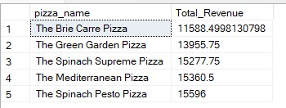

# I. Top 5 Pizzas by Quantity

SELECT Top 5 pizza_name, SUM(quantity) AS Total_Pizza_Sold

FROM pizza_sales

GROUP BY pizza_name

ORDER BY Total_Pizza_Sold DESC

## *Output*

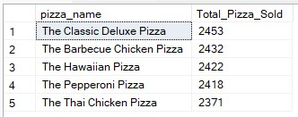

# J. Bottom 5 Pizzas by Quantity

SELECT TOP 5 pizza_name, SUM(quantity) AS Total_Pizza_Sold

FROM pizza_sales

GROUP BY pizza_name

ORDER BY Total_Pizza_Sold ASC

## *Output*

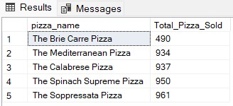

# K. Top 5 Pizzas by Total Orders

SELECT Top 5 pizza_name, COUNT(DISTINCT order_id) AS Total_Orders

FROM pizza_sales

GROUP BY pizza_name

ORDER BY Total_Orders DESC

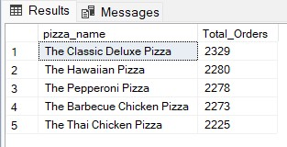

# L. Borrom 5 Pizzas by Total Orders

SELECT Top 5 pizza_name, COUNT(DISTINCT order_id) AS Total_Orders

FROM pizza_sales

GROUP BY pizza_name

ORDER BY Total_Orders ASC

